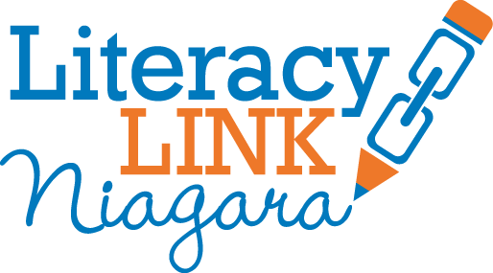
Niagara Leaders in Adult Learning Awards Breakfast
Volunteer Adult Literacy Leader Nominations Form
Please complete and return to operations@literacylinkniagara.ca by May 19, 2016.
*Nominee – person being nominated to receive award
*Nominator(s) – person(s) who are writing and submitting the application

Name of the Nominee:
Phone Number of the Nominee:
Email of the Nominee:
Literacy Organization(s) involved with:
Name of the Nominator:
Phone Number of the Nominator:
Email of the Nominator:

Length of service as volunteer in Adult Literacy:

Please explain the role(s) the Nominee has played in Adult Literacy (Tutor, Office Volunteer, Guest Speaker etc.).

Please explain why the Nominee should be recognized as a Volunteer Adult Literacy Leader.

Thank you for your Nomination!
Nominees will be contacted about award selection by May 30, 2016. Award winners will receive a complimentary ticket to the breakfast on June 13, 2016 at Amici’s Banquet Centre.

