  - Final Report – February 2012

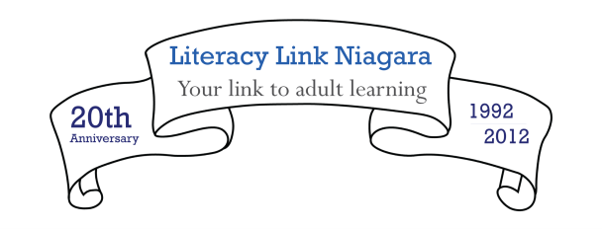
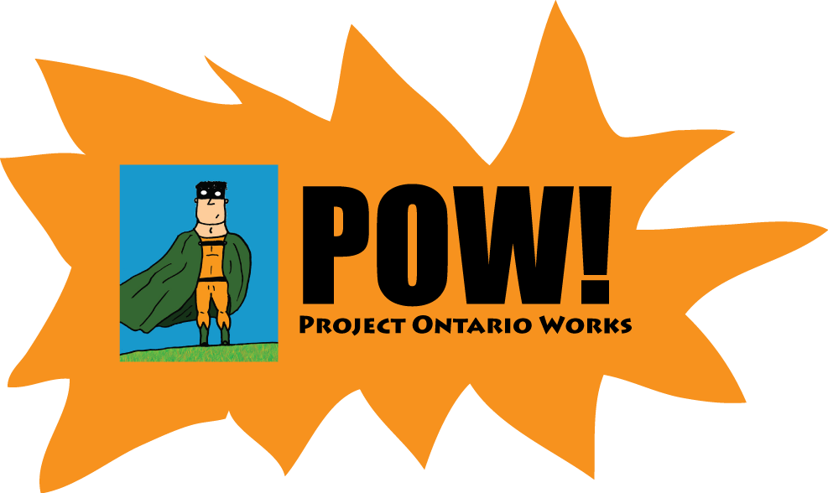
Executive Director
Gay Douglas Broerse

Project Lead
Ashley Hoath

Project Support
Jacklyn Catterick
Contents
Overview 2
Project Overview 2
The Ontario Works System 3
Historical Relationships 4
Methodology 5
Data Collection 5
Challenges 5
Advisory Committee 6
Findings 8
Literature Review 8
Surveys 10
Network Survey 10
Program Survey 12
February Training 13
Materials 15
Best Practices Guide 15
Resource List 15
Indicators Checklist 15
Quick-screen tool 16
Sensitive Language Tip Sheet 17
Client Survey 17
Common Referral Form 17
Ontario Works and Employment Ontario Referral Protocol 18
Ontario Works Awareness and Compassion Fatigue workshop 19
Next Steps 20

Overview

Project Overview
Over the past decade, Literacy Link Niagara has operated an assessment and referral program for Ontario Works (OW) clients in the Niagara Region on a fee-for-service basis. Other municipalities, literacy organizations and regional networks partner to better serve the literacy needs of Ontario Works clients across the province. The result of these local relationships means that there aren’t consistent processes and procedures in place across the province.
This project wanted to address OW and literacy relationships that have developed in Ontario and ask
- how did these relationships develop?
- what were the challenges and what are the successes?
A goal of the project was to provide areas with limited partnerships with tangible evidence of how strong partnerships were developed (referrals, programming, supports, tools) as well as evidence of the partnerships’ successes.
This project also looked at the new population that is emerging within some OW caseloads – clients with strong histories of attachment to the labour market who have exhausted their EI and cannot find a place for their skill sets within the current economy.
Project Activities included
- recruitment of a province wide advisory committee
- an international literature review
- surveys with Literacy & Basic Skills and support agencies to discover best practices and gaps of partnerships across the province
- regional discussions of new OW client profile, best practices and gaps of partnership (Niagara)
- survey of motivations for appointment attendance and next steps of clients who are assessed in a Learning Choices appointment (objective referral service provided to OW clients by Literacy Link Niagara)
- discussion around developing a protocol on client referral by Employment Ontario agencies to Learning Choices appointments
Project Deliverables included
- best practices guide to help develop new partnerships
- literacy information document for Ontario Works staff
- revised Ontario Works literacy pre-screen reflecting the Ontario Adult Literacy Curriculum Framework
- protocol on client referral by Employment Ontario agencies to Learning Choices appointments (in progress)

The Ontario Works System
Ontario Works is a social assistance program run by the Province of Ontario. It is a program of the Ministry of Community & Social Services. Its main goal is to provide income support for people who cannot support themselves due to lack of employment. Ontario Works provides financial support as well as employment support to help people become independent through sustainable employment. According to the Ontario Works website, to receive support a person must
- live in Ontario
- need money right away to help pay for food and shelter
- be willing to take part in activities that will help you find a job
Ontario Works offices are managed locally and may vary in practices and partnerships from region to region. Ontario Works works with a variety of local agencies to provide a holistic approach when supporting their clients.

Historical Relationships
Many clients who access adult literacy programs are on Ontario Works. 65% of social assistance recipients in Canada have low literacy skills.
Because Ontario Works offices are managed locally, adult literacy networks and programs have had to develop their own practices and partnerships with the local Ontario Works offices. While some adult literacy networks have strong partnerships with Ontario Works, other areas have limited or no partnerships.
The purpose of the best practices guide is to help adult literacy networks and programs identify new ways to partner with their local Ontario Works offices and try to promote more common practices across the province of Ontario.

Methodology

Data Collection
Literacy Link Niagara collected research on best practices between adult literacy and Ontario Works in several ways. An international and national literature review was used to identify successful partnership strategies from outside of Ontario. Some of these strategies were piloted in Niagara during the project to determine if they may be successful in Ontario.
Literacy Link Niagara also surveyed adult literacy networks and programs to help identify challenges and successes related to Ontario Works partnerships.
Working with their Ontario Works local offices, Literacy Link Niagara piloted new best practices that had been identified as needed in recent years. Management and front-line staff were consulted about how to implement these best practices.
When necessary, Literacy Link Niagara asked for feedback and data from other adult literacy networks.

Challenges
While Literacy Link Niagara feels that this project has allowed the identification, creation and implementation of many best practices between adult literacy and Ontario Works, two key challenges to project have been identified.
The Adult Literacy and Ontario Works systems often move at different speeds. Because of the large scale of the Ontario Works system, Literacy Link Niagara found that even if local Ontario Works managers and front-line staff thought that a best practice would be beneficial to use, often implementation was not an option due to procedural constraints of the Ontario Works system.
Literacy Link Niagara also felt that it was not able to pilot some of the best practices locally it had identified within the time period of the project. By the time best practice research was completed and potential best practices were identified, the project was more than 50% complete. Even the best practices that were implemented could have stronger evidence of success if the length of piloting was longer. For this reason, Literacy Link Niagara is continuing the implementation of many best practices beyond the length of the project to better strengthen the relationships between the network and the local Ontario Works offices.

Advisory Committee
Literacy Link Niagara assembled an advisory committee of people from across Ontario who have a vested interest in the success of partnerships between adult literacy and Ontario Works. It was important that the committee represented staff from adult literacy networks, adult literacy programs, Ontario Works and additional agencies that support or participate in local partnerships (Training Board, Employment Ontario Employment Service Provider, Action Centre.) The advisory committee gave input on the project direction and deliverables through three phone calls throughout the project.
The Project Ontario Works (POW) Advisory Committee included
Jennine Agnew-Kata, The Literacy Network of Durham Region
Cindy Buckley, Niagara Action Centre
Stan Drobnich, Employment Help Centre
Christine Eaton, Port Cares
Tim Grawey, Ontario Works, Social Assistance and Employment Opportunities, Niagara Region
Laura Hamilton, Ministry of Training, Colleges & Universities
Tracey Meszaros, Niagara Workforce Planning Board
Doug Noyes, Literacy Link Eastern Ontario

Findings

Literature Review
An international and national literature review was used to identify successful partnership strategies from outside of Ontario. Key findings of the review included
- grassroots initiatives that heavily involved clients in programming creation and advocacy were heavily used in the United States
- niche programs were often created to target community issues and to support specific groups including women and mothers
- retention of Social Assistance clients is an issue across most programs and engaging clients in programs quickly (under 3 weeks) is very important
- many high level recommendations were made without discussing how they could be implemented on the ground level and with limited tangible suggestions
Some of the strategies were piloted in Niagara during the project to determine if they may be successful in Ontario. One strategy implemented was a client survey from “Laboring to Learn” that identified client motivation for attending programs. Over 5 months, the Literacy Link Niagara assessor used this survey with 65 Learning Choices clients to determine their motivations. Literacy Link Niagara was quite surprised by the results. Clients were given the opportunity to select up to three options that answered the question, “Why did you attend the Learning Choices appointment today?” Clients were able to choose from the following answers
- To improve myself
- To get out of the house
- To be part of my community
- To try something new
- For my children
- To increase my literacy skills
- To get a job
- To increase my income
- To go into an educational program - Grade 12, College/University
- Someone told me to attend – Please tell us who ________________
The chart below shows the results of the survey.

Only one client identified that someone told them to attend. Literacy Link Niagara staff expected this to be much higher. This new knowledge will help staff better understand the client experience and shape new program changes moving forward.
The options for the survey were adapted from “Laboring to Learn: Women’s Literacy and Poverty in the Post-Welfare Era” by Lorna Rivera, an in-depth case study of an adult literacy program in Boston’s Dudley Street neighbourhood. The case study identified that adults attend literacy programs for one or more of the following reasons. The reason is identified first and the brackets contain the clearly written statement for clients to check off in the survey.
- Self-Improvement (to improve myself)
- Diversion (to get out of the house)
- Community/church involvement (to be part of my community)
- Launching (to try something new)
- Family responsibility (for my children)
- Literacy development (to increase my literacy skills)
- Job advancement (to get a job)
- Economic need (to increase my income)
- Educational advancement (To go into an educational program - Grade 12, College/University)
- Urging of others (someone told me to attend – please tell us who _______)

Surveys
Literacy Link Niagara surveyed adult literacy networks and programs to help identify challenges and successes related to Ontario Works partnerships. Surveys were distributed through the adult literacy networks. The results of both surveys are below.

Network Survey
12 people responded to the survey.
82% are currently working with Ontario Works. Activities include
- presentations to staff
- involvement in Literacy Service Planning
- input on projects and programs
- objective placement assessments
36% of networks have made attempts to build relationships with OW that have been unsuccessful. Many identified that they have problems getting invited to important meetings with the “right” people.
70% of networks have Ontario Works representation at Literacy Service Planning meetings. 70% send Ontario Works the final Literacy Service Plan. 50% have Ontario Works assistance in the development of the Literacy Service Plan.
Networks that were successful in Ontario Works partnerships were asked to provide suggestions for success to networks that were having trouble. Responses included
- involving Ontario Works in many ways and at many levels
- following up with emails and phone calls
- building a connection with one Ontario Works staff person
- acknowledging that if you build a relationship with Ontario Works that includes fee for service work, you are a vendor, not a partner
- understanding that priorities may not match – Ontario Works may have different pressures and their staff are swamped
- the importance of getting everything in writing so that everyone is on the same page

Program Survey
117 people responded to the survey.
86% are currently working with Ontario Works. The majority of these relationships are about referrals. Most are informal. Quite a few identified that they report on the status of the learner’s progression through the Literacy & Basic Skills program to Ontario Works Case managers.
16% are currently offering boutique training delivered specifically to Ontario Works clients. Most of these programs are pre-employment preparation.
22% have made attempts to build relationships with Ontario Works that have been unsuccessful. Ontario Works turnover was a major issue. Many people identified the importance of having a personal relationship with an Ontario Works staff person. Many have made presentations to staff without seeing an increase in referrals.
Programs that were successful with their Ontario Works partnerships were asked to share suggestions for success to programs that were having difficulties building partnerships. Suggestions included
  - having regular meetings and contact with Ontario Works staff
  - sharing space – co-location
  - having a point person in the Ontario Works office
  - tying all conversations to employment outcomes because this is the language that case managers are using
  - being sensitive to the Ontario Works client experience
  - having open communication with all partner agencies who support the client
  - being persistent

February Training
On February 16, 2012, Literacy Link Niagara held training for adult literacy networks to share the results of the project and gather additional information about best practices at the Holiday Inn Hotel & Convention Centre in St. Catharines, Ontario. Additional attendees included Ontario Works staff, advisory committee members and a representative from the Ministry of Training, Colleges and Universities.
Attendees provided feedback on the quick-screen tool and additional best practices information. The best practices feedback is reflected in the notes below.
- Other best practices
  - Compile list of Ontario Works related projects and resources
  - Include literacy information in monthly cheque inserts
  - Have staff attend Bridges Out of Poverty training
  - Explanation of referrals
  - Engage in technology – professionally and effectively

- Opportunities for success
  - Involve Ontario Works representatives in Literacy Service Planning, Board and other groups
  - Use Indicators Checklist
  - Co-locate with Ontario Works
  - Co-locate with Employment Services
  - Communication and connections are key
  - Policies and legislation that require collaboration in every community

- Greatest Challenges
  - Choosing one assessment tool to serve all clients
  - Levelling materials in Employment Services programs to make more accessible to Ontario Works clients
  - Ontario Works creating their own “literacy” programming
  - Designing programming that meets all individual’s changing needs in all structures
  - Ontario Works case managers remaining unbiased and non-judgemental towards changing client base (generational, laid off workers)
  - Relationship building in the long term is not effective because it is based on personalities not systems

- Social Assistance Reform – should standardized assessment exit?
  - Literacy should develop and implement assessment

Materials
Literacy Link Niagara produced several materials that can be used to help adult literacy networks and programs strengthen current or create new relationships with Ontario Works. Descriptions of the materials produced are below.

Best Practices Guide
Literacy Link Niagara created a best practices guide called “Building partnerships between Adult Literacy & Ontario Works.” The best practices guide included findings from the best practices research presented in a way that offered tangible suggestions for implementation and materials to promote partnerships. The best practices guide will be distributed to adult literacy networks and will be available for download on the Literacy Link Niagara website in March 2012.

Resource List
A resource list from the best practices guide will be available on the Literacy Link Niagara website in March 2012. Additional resources will be added to the website as they are discovered.

Indicators Checklist
An Indicators Checklist used by Literacy Link Niagara to help Ontario Works case managers understand how low literacy issues may present themselves in client’s can be easily modified and distributed across the province. The Indicators Checklist is included in the best practices guide and will be available on the Literacy Link Niagara website.

Quick-screen tool
Literacy Link Niagara was initially part of the development of the Ontario Works mandatory literacy screening test over a decade ago. When reviewing the processes of adult literacy and Ontario Works, it became clear that the screening test no longer reflects what is going on in the literacy field. The screening test was originally created to help a case manager quickly assess the literacy skills of their client, so they could determine is a referral to an adult literacy program should be made. While this function was still necessary, Literacy Link Niagara decided it was important to create a new tool that reflected the Ontario Adult Literacy Curriculum Framework (OALCF).
The tool has been designed to look like an authentic document (a cell phone bill) to make clients more comfortable instead of asking the client to complete more traditional “school-type” questions like math equations. If forwarded to an adult literacy program, a practitioner will get a quick “snapshot” of the client’s skill levels related to the new framework.
Initially, Literacy Link Niagara wanted to pilot the tool in Niagara and in three other areas in Niagara utilizing other adult literacy networks. Although Ontario Works offices liked the idea of the tool, all offices did not feel that they could pilot the tool before the end of February 2012. For this reason, Literacy Link Niagara asked three networks to validate the tool by providing feedback on the tool. Comments were very positive and Literacy Link Niagara made changes to the tool to reflect the feedback.
Literacy Link Niagara received additional feedback from networks at the February training with networks. Literacy Link Niagara staff are attending a task complexity workshop presented by Project READ in spring 2012. Literacy Link Niagara will revise the documents using the feedback and lessons learned from the workshop in spring 2012. The updated version will be available on the Literacy Link Niagara website and submitted to the Ministry of Training, Colleges & Universities. After the revision, Literacy Link Niagara will approach the Ontario Municipal Social Services Association to discuss future piloting opportunities. The current version of the tool can be found in the best practices guide and will be available on the Literacy Link Niagara website in March 2012.

Sensitive Language Tip Sheet
It is important that literacy and negative experiences with traditional schooling also be identified as an area where sensitivity training is needed. To help case managers understand what to say and what not to say, Literacy Link Niagara has developed a Sensitive Language tip sheet. The tip sheet is available in the best practices guide and will be on the Literacy Link Niagara website in March 2012.

Client Survey
The client motivation survey discussed previously in this document can easily be modified to survey clients in literacy programs across the province. The survey is available in the best practices guide and will be on the Literacy Link Niagara website in March 2012.

Common Referral Form
A common belief is that by supporting clients using a holistic, case-managed approach they will have increased community participation and develop long-term capacity for success.
A common referral form template was developed based heavily on a form from Project READ Literacy Network and on templates from other networks and input from local programs. The template is available in the best practices guide and will be on the Literacy Link Niagara website in March 2012.

Ontario Works and Employment Ontario Referral Protocol
In January 2012, Literacy Link Niagara held a referral protocol day to discuss referrals with our Employment Service Providers, Ontario Works and Literacy and Basic Skills (LBS) agencies. The purpose of the meeting was to facilitate discussion between Ontario Works, Employment Services providers (Management and Front-line) and Literacy Link Niagara staff about referral protocol and literacy assessment opportunities for Employment Service provider clients receiving OW.
In recent months, Literacy Link Niagara had been contacted by Employment Service frontline staff who wanted to know how to get an objective referral assessment for their Ontario Works clients paid for by Ontario Works. Literacy Link Niagara wanted to discuss formalizing the process. All partners were very interested in formalizing and discussions took place as to what kind of referral process would make sense.
In small groups, participants discussed whether a linear or cyclical model of referral would be most beneficial to clients and staff. Literacy Link Niagara learned that Employment Service providers and Ontario Works were interested in a cyclical model of referral that was transparent to all parties involved. It was decided that the notes from the meeting should be given to a small group of front-line staff to recommend a model that would most make sense in their daily activities. Literacy Link Niagara will be calling a meeting in early March to do this.
Results and materials produced from this process will be made available to networks via Central Desktop after the process has been formalized.

Ontario Works Awareness and Compassion Fatigue workshop
Literacy Link Niagara in partnership with Literacy Link South Central is currently creating an Ontario Works Awareness and Compassion Fatigue workshop. The workshop will be available to adult literacy networks in March/April 2012 for training and to create awareness in their communities.

Next Steps
The best practices learned during this project and the materials developed will continue to be utilized in the Niagara region. Literacy Link Niagara is committed to remaining aware of new practices and adapting the partnership with the local Ontario Works offices to best serve clients.
As outlined throughout this document, immediate next steps include
- finishing the Ontario Works and literacy presentation including a piece on compassion fatigue and distributing to adult literacy networks
- revising the quick-screen tool and sharing it and the result of this project with the Ontario Municipal Social Services Association
- completing a new referral process and protocol with literacy, Employment Services and Ontario Works and sending notes and materials created to adult literacy networks if they are interested in replicating

