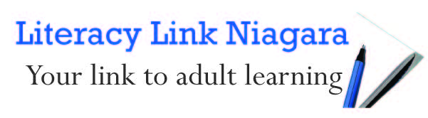

Sensitive Language for a Sensitive Topic
There is no denying the power of words. The words we use change based on who we are speaking to and in different environments. Use the suggestions in this chart when working with a client with potential literacy issues.
What not to say | What to say
Literacy | - skills upgrading/training
Illiterate | - difficulty with reading, writing, communications and math
Go back to school | - upgrade your skills  - improve your skills as a first step before a job search
School | - skills upgrading/training
Stupid or Slow Learner | - have learning difficulties  - have learning challenges  - have barriers to learning including a rough personal life  - had trouble in early education
I.Q./Intelligence Tests/Test | - skills based assessment to measure strengths and identify areas that can be improved  - find your current level, identify strengths and areas you can improve in  - screening tool
Send to program X | - offer an opportunity to attend an upgrading program
Fail/failed | - unsuccessful  - the program was not the right fit

