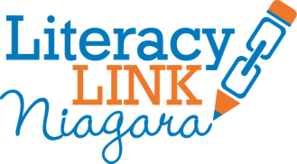

Working with Learner Focus Groups
Literacy Link Niagara may conduct learner focus groups through project funding and/or at the request of local adult literacy programs. Local adult literacy programs will be included in every step of learner focus groups including
- question development
- learner recruitment
- scheduling
- follow-up
- report writing
Literacy Link Niagara staff will conduct learner focus group in a casual manner that reduces hierarchy between staff and learners. Staff will dress as outlined in the Human Resources policy. This policy states that all staff working directly with learners shall dress in casual/casual-business clothing. Learners and staff will sit at the same table. All questions should be open to the entire group. Learners should be given every opportunity to express themselves and make additional comments.
Everyone who participates in a focus group will receive a copy of the follow-up report. This report may include notes, summaries and next steps. Reports may be sent to the hosting program for distribution to participants.
Literacy Link Niagara will not collect learner names. Learners and programs will not be named in project reports. Programs may be described by stream and sector.

