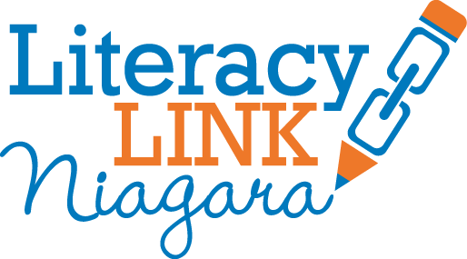
Niagara Leaders in Adult Learning Awards Breakfast
Community Partner in Literacy Nominations Form
Please complete and return to operations@literacylinkniagara.ca by May 19, 2016.
*Nominee – person being nominated to receive award
*Nominator(s) – person(s) who are writing and submitting the application

Name of the Nominee:
Phone Number of the Nominee:
Email of the Nominee:
Literacy Organization(s) involved with:
Name of the Nominator:
Phone Number of the Nominator:
Email of the Nominator:

Length of partnership with Literacy:

Please explain how the community partner has supported literacy in Niagara.

Thank you for your Nomination!
Nominees will be contacted about award selection by May 30, 2016. Award winners will receive a complimentary ticket to the breakfast on June 13, 2016 at Amici’s Banquet Centre.

